MCT Omnichannel Experience: Experience Strategy (XS) Phase II Facilitation Guide

Last Updated: July 30, 2021   
Primary POC: Vidya Mantrala ([vidya.mantrala@va.gov](mailto:vidya.mantrala@va.gov))

Table of Contents

Overview 2

Key Objectives 2

Testing Method 2

Research Activities 2

Facilitation Guide 2

Introduction (5 minutes) 2

Agenda (5 minutes) 3

Background Questions (3 minutes) 4

VA Engagement Questions 4

Veteran Facing CX Dashboard 4

Conclusion (5 minutes) 9

Close Out 10

**[Note for DSVA: This is an initial version of this facilitation guide and may be subject to change to reflect user feedback.]**

# Overview

### Key Objectives

1. Understand how can VA ensure that the Veteran, caregiver, and beneficiary experience is represented in the prioritization and long-term strategic planning for MCT platforms and products?
2. Learn how might we streamline the customer experience across VA touchpoints, so they spend less time, effort, and experience fewer steps from issue to resolution by prototyping a Veteran and CSR facing Customer Experience Dashboard?

### Testing Method

The objective of this phase is to expand on research findings specifically related to transparency, triage and escalation, and user channel preferences. Below are a few testing methods for collecting qualitative data on (1) user expectations for what and how information is used in the design and (2) the desirability of certain functions, feature, or preferences.

### Research Activities

# Facilitation Guide

## Introduction (5 minutes)

***\*Note to Facilitator to turn on Camera and enable screensharing.***

***Introduction Script.***

Thank you for taking the time to give us your feedback. My name is [*insert name*], and I will be facilitating today’s testing session. [*Optional: Introduce government observer, notetaker, and others present.*]

We are working with VA to improve the VA contact center experience. Our goal is to gather feedback on what information or resources specifically related to your contact center experience might help Veterans, Caregivers, and beneficiaries in accomplishing your goals. Specifically, this means recalling experiences where you had to engage directly with VA customer support resources.

With your permission, we are going to document this session using written notes, screenshots, audio, and/or video recording. We will only use the information you share with us for research and analysis, and we will not share it with anyone outside of our project team at VA. Do you understand these guidelines and consent to this interview being documented via written notes, screenshots, audio and/or video recording?

[ ] Yes, consent provided

[ ] No, do not record

Great, thank you. Before I go over the agenda for today’s session, I have two other things to note:

1. **[Observers]** My colleague will be observing and taking notes on the call. This helps me to stay involved and focus on our conversation. Is that ok with you?
2. **[Stopping & Aggregation]** I also wanted to let you know that your participation is entirely voluntary, and we can stop at any time. You are also welcomed to decline or skip any question. In our notes, we will remove any personally identifying information such as your name or benefit eligibility status, and combine them with other participants’ information, so no feedback will be directly tied to you. Is that alright?

***\* Note to Facilitator to notify the participant once the recording has started.***

Now that the recording has started, can you please state your name and let us know whether you consent to a recording of this session?

### Agenda (5 minutes)

To give a quick **overview** of what we’ll run through, here’s our agenda for today:

This session is set to be no more than one hour, during which we will do a couple of activities together using an online collaboration tool, MURAL. Do you feel comfortable using a visual online tool? If so, please open a Google Chrome window and paste this link from the chat: [mural link].

In a moment, we will walk through some questions regarding the screens that you see in MURAL. If you are having difficulty navigating to that link, I can share my screen. [If the facilitator is screensharing] If you are unable to see my screen, please let me know, sometimes the zoom on this tool makes everything tiny.

You can’t do anything wrong here, and you cannot break this tool. We plan to walk through each concept one by one for each prototype and its components and ask you questions regarding specific features and information.

As you go through today’s session, please share your feedback as much as possible. We will describe the concept but we want to hear your feedback on this concept specifically as they apply to your life and experience. We especially want to know if there’s anything you like or don’t like, or if there’s anything you find confusing. We want your complete honesty. Following each task, I will ask a few follow-up questions before moving on to the next. We will document the conversation using MURAL’s notetaking capabilities.

After we complete all the prototypes, I'll ask you about your overall impressions of the experience and take note of any general comments you have. I can’t stress enough your honest feedback will help us make better products for the VA. Please don’t hold back. Even small or nitpicky things are helpful. You will not hurt our feelings if you are brutally honest!

Do you have any questions at this point?

## Background Questions (1-2 minutes)

Before we begin, I have just a few background questions. Please note you have the option to skip or decline any of these questions.

### VA Engagement Questions

1. When was the last time that you contacted VA for customer service (this could be in-person, over the phone, using email or messaging, or even snail mail)?
   1. In the last week/day
   2. Last month
   3. 2 to 6 months
   4. More than 6 months ago
   5. More than a year ago

Thank you for your answers so far. Now we can move on to the testing activity.

## Veteran Facing CX Dashboard

The first concept you will be testing is a Veteran facing CX dashboard. We will walk you through what you might see at each stage of the CX Dashboard lifecycle and get your feedback on the key features or content you would like us to consider as we build this product.

**Setting Expectations (10 minutes)**

1. **As a New User**
2. What was the first incident you had to reach out to a VA contact center for? How did you reach out?
3. What types of information did the Customer Service Representative ask you for? What types of information did you expect to share?
   1. What did you expect from the agent during your first conversation with them?
4. Was your issue resolved? How did you find out? How did you expect to find out?
5. If you had to wait for resolution, did you check in on the status of your incident as it was being processed?
   1. Would you have liked to?
   2. What information did you expect to receive in between?
6. **As an experienced User**
7. What do you expect the call center agents to already know about you?
8. How important is it for you to:
   1. Have a historical record of previous interactions with the VA contact centers?
      1. In what form would you like to see those interactions?
      2. Do you want to see your entire history or a certain time period?
      3. How would you want to use your interaction history?
   2. Submit an issue without having to go through speaking with an agent?
9. What is the most annoying part about interacting with the VA customer support services? What is the best part about it?

**Dashboard Design (25 minutes)**

*We are now going to design your VA Dashboard with you. First, we will show you a list of different information and ask you to pick the types of information that you believe are critical to you being able to work with VA Customer Support Services.*

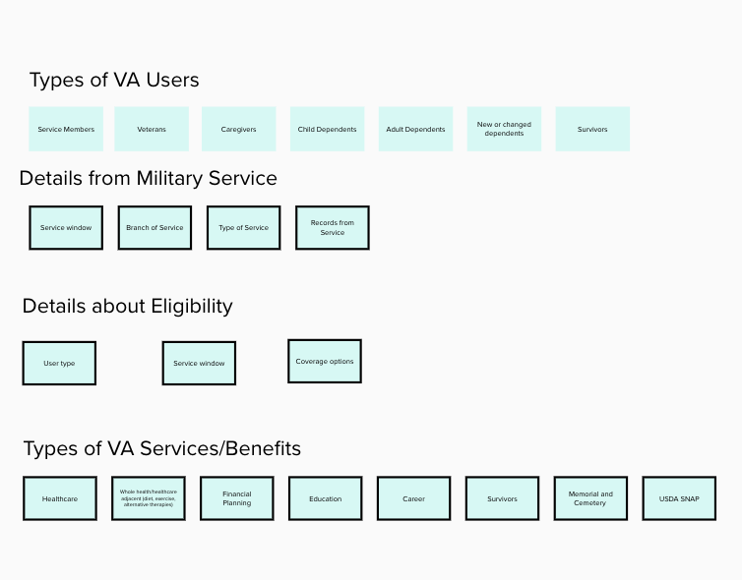

*For each category of information, please tell us the following:*

1. What information do you think should be shared with any VA Customer Service Representative?
2. Is there important information that should be limited to certain departments, areas of VA, or individual employees?
3. What information would be helpful to you when reaching out to the VA to resolve a specific issue?

*Now let’s pretend we are logging into a personal dashboardl from VA.gov. Link*  
  
  
**Personal information (about me section)**

1. *What would you expect to be able to access and change about your personal information (Name, pronouns, honorifics etc.)?*
2. *Once you tell VA do you expect everyone to call you the same way?*
3. *Do you want the agent to be aware of any disabilities? What should they know about you when speaking with you?*
4. *How do you want to be addressed?*
5. *How important is it to you what they call you?*
6. *What do you want the VA to know about you?*
7. *What would you like to share with the VA about your display preferences?*
8. *What would you like to share with the VA about your channel preferences?*

**Dashboard View**

Alerts

1. Think back to a time when you last talked with a VA customer service representative. Either during or after that conversation, was there anything that you wanted to be notified about?
2. What is most important about your VA interactions that you would like to see first or in a specific way?

Current Benefits:

1. Should all benefits you are enrolled in be listed here?
2. Have you ever used an online tool or assistant to find the best contact at VA to help solve your issue? How did it go for you?
3. If self-service tools were available to help you manage your benefits, where would you like to see them?
4. What do you consider to be self-service?

**VA Customer Service Interaction History:**

*How important are the following features?*

1. POC for different incidents
2. Department
3. Time of incident
4. Click incident to get transfer history
5. What would you use an interaction history for?

Open Incidents:

1. Level of detail (feed vs, paragraphs)?
2. Opened, Pending Review, Needs further action, pending close (statuses)?
3. Status bars?

***Are there features that you would like to see that are not included here?***

1. *Are there features that are irrelevant to your experience that you wish to remove?*
2. *How would you use a dashboard like this? In what ways is it helpful or unhelpful?*
3. *What parts of this dashboard do you expect an agent to be able to look at? Do you expect the agent to have “Read only” access or “Read/write” access?*
4. *Recommended services dashboard*

**Recommendation Engine**

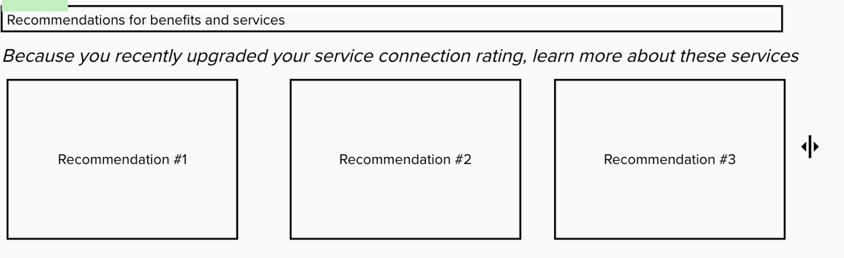

1. If you could receive proactive notifications about potential services you may be eligible for, how would you wish to receive those notifications? Walk us through how these notifications could fit into your experience (if at all).
2. What (if anything) would you like the VA to track closely in order to get you information about the services that you could be eligible in the future?

## Conclusion (5 minutes)

1. Any other comments you'd like to mention before we wrap up?

## Close Out

Great, thank you for your feedback today. [*optional: I’d like to open it up to my teammates on the line to see if they have any questions that they might like to ask*.]

Well, again, on behalf of our team, I’d like to thank you for your time today. Your feedback and insights will play an important role in helping us build an accessible and helpful chatbot experience.

Thank you. Enjoy the rest of your day! Goodbye J